December 5th 2018

Deliverable 4: Final Report

SEG2105A/B – Introduction to Software Engineering
Fall 2018

School of Electrical Engineering and Computer Science
University of Ottawa

Course Coordinator: Dr Miguel A. Garzon

Fnord
Liam Wilford 8807534
Graham Littlewood 300013668
Subhan Sediqi 6789148
Natalia Maximo 8756866

Table of Contents
Introduction 3
UML Diagram 3
Contributions and Corrections 3
Roles 3
Contributions 5
App Screenshots 5
Lessons Learned 8

Introduction
Fnord is an Android application for home owners who are tired of doing chores. This application aims to provide users with an easy to use system to hire other people to do services for them.

The aim of this report is to outline the development process and the functionalities of the Fnord app. It includes contributions from team members, the app’s (UML) design diagram as well as a walk-through of the app’s UI.

UML Diagram
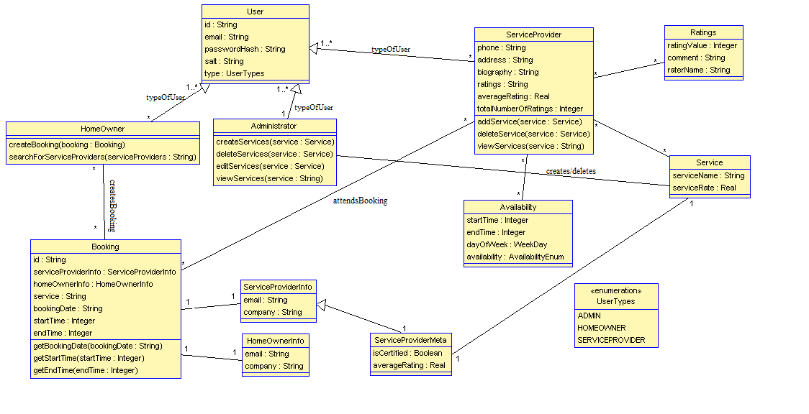

Contributions and Corrections

Roles

Team Member | Deliverable 1 | Deliverable 2 | Deliverable 3 | Deliverable 4
Liam Wilford 8807534 | UI (Activities) | UI (Activities), toasts and fixes | UI (Activities) | Service search, Rating comments
Graham Littlewood 300013668 | Text field validation | 5 unit tests, CircleCI integration | Unit tests, Availability logic | Unit tests, Homeowner bookings, Final Report
Subhan Sediqi 6789148 | APK testing | App rewrite, UML | UML, User information | Rating UI, Service rating logic and structure
Natalia Maximo 8756866 | Backend (account creation) | Text field validation, | DB implementation, Availability logic, User information | DB implementation, Booking logic and structure

Contributions

Team Member | Deliverable 1 | Deliverable 2 | Deliverable 3 | Deliverable 4 | Total Git Contributions
Liam Wilford 8807534 | 20%* | 25% | 25% | 25% | (Leesteak)  2,872 ++  312 --
Graham Littlewood 300013668 | 20%* | 25% | 25% | 25% | (NGnius)  1,015 ++  295 --
Subhan Sediqi 6789148 | 20%* | 25% | 25% | 25% | (ssedyl)  2,665 ++  1,657 --
Natalia Maximo 8756866 | 30%* | 25% | 25% | 25% | (taliamax)  11,476 ++  11,455 --
* fifth member contributed 10% to Deliverable 1

App Screenshots
Welcome screen  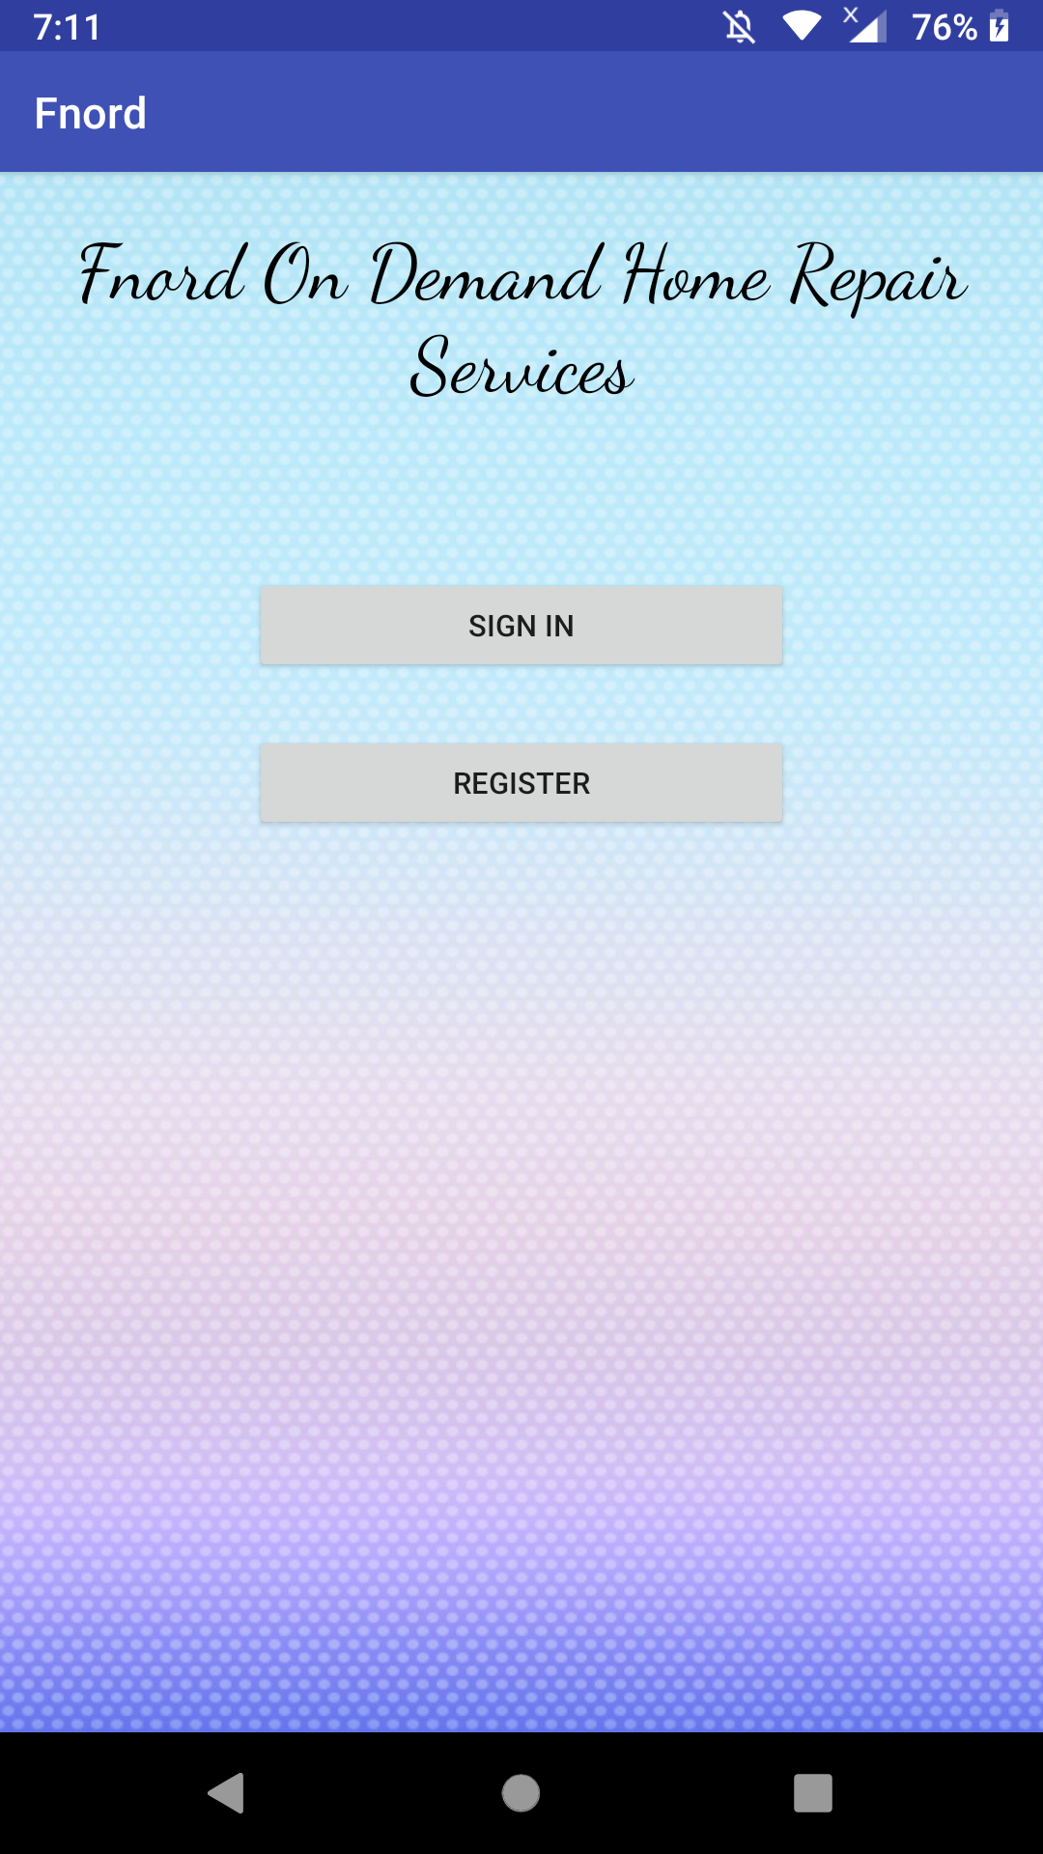 | Sign in activity  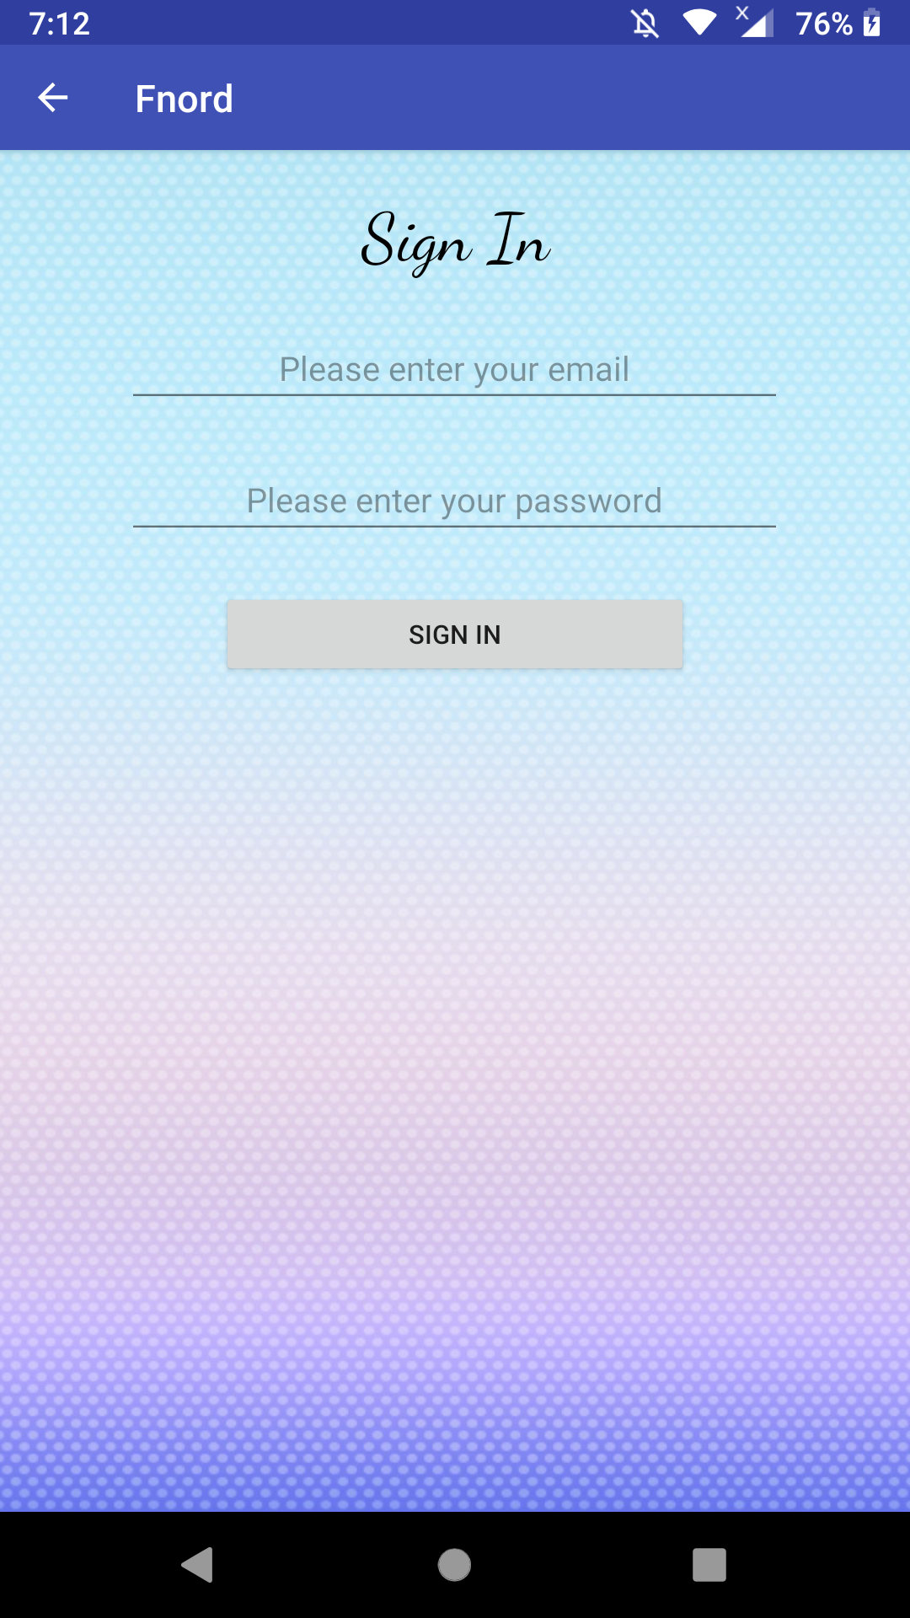 | Sign up activity  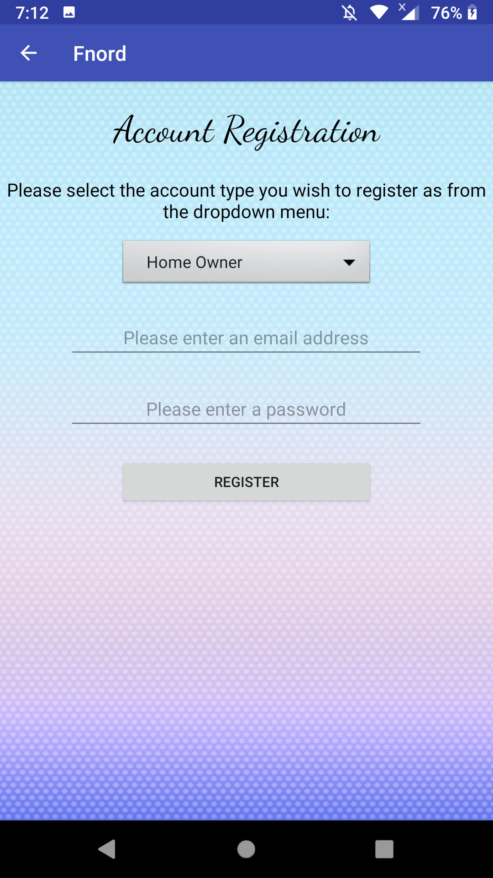
ServiceProvider landing  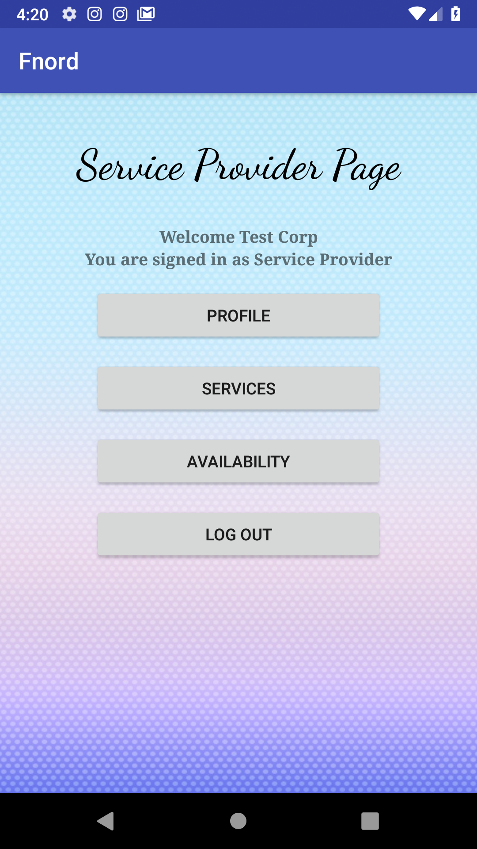 | ServiceProvider profile activity  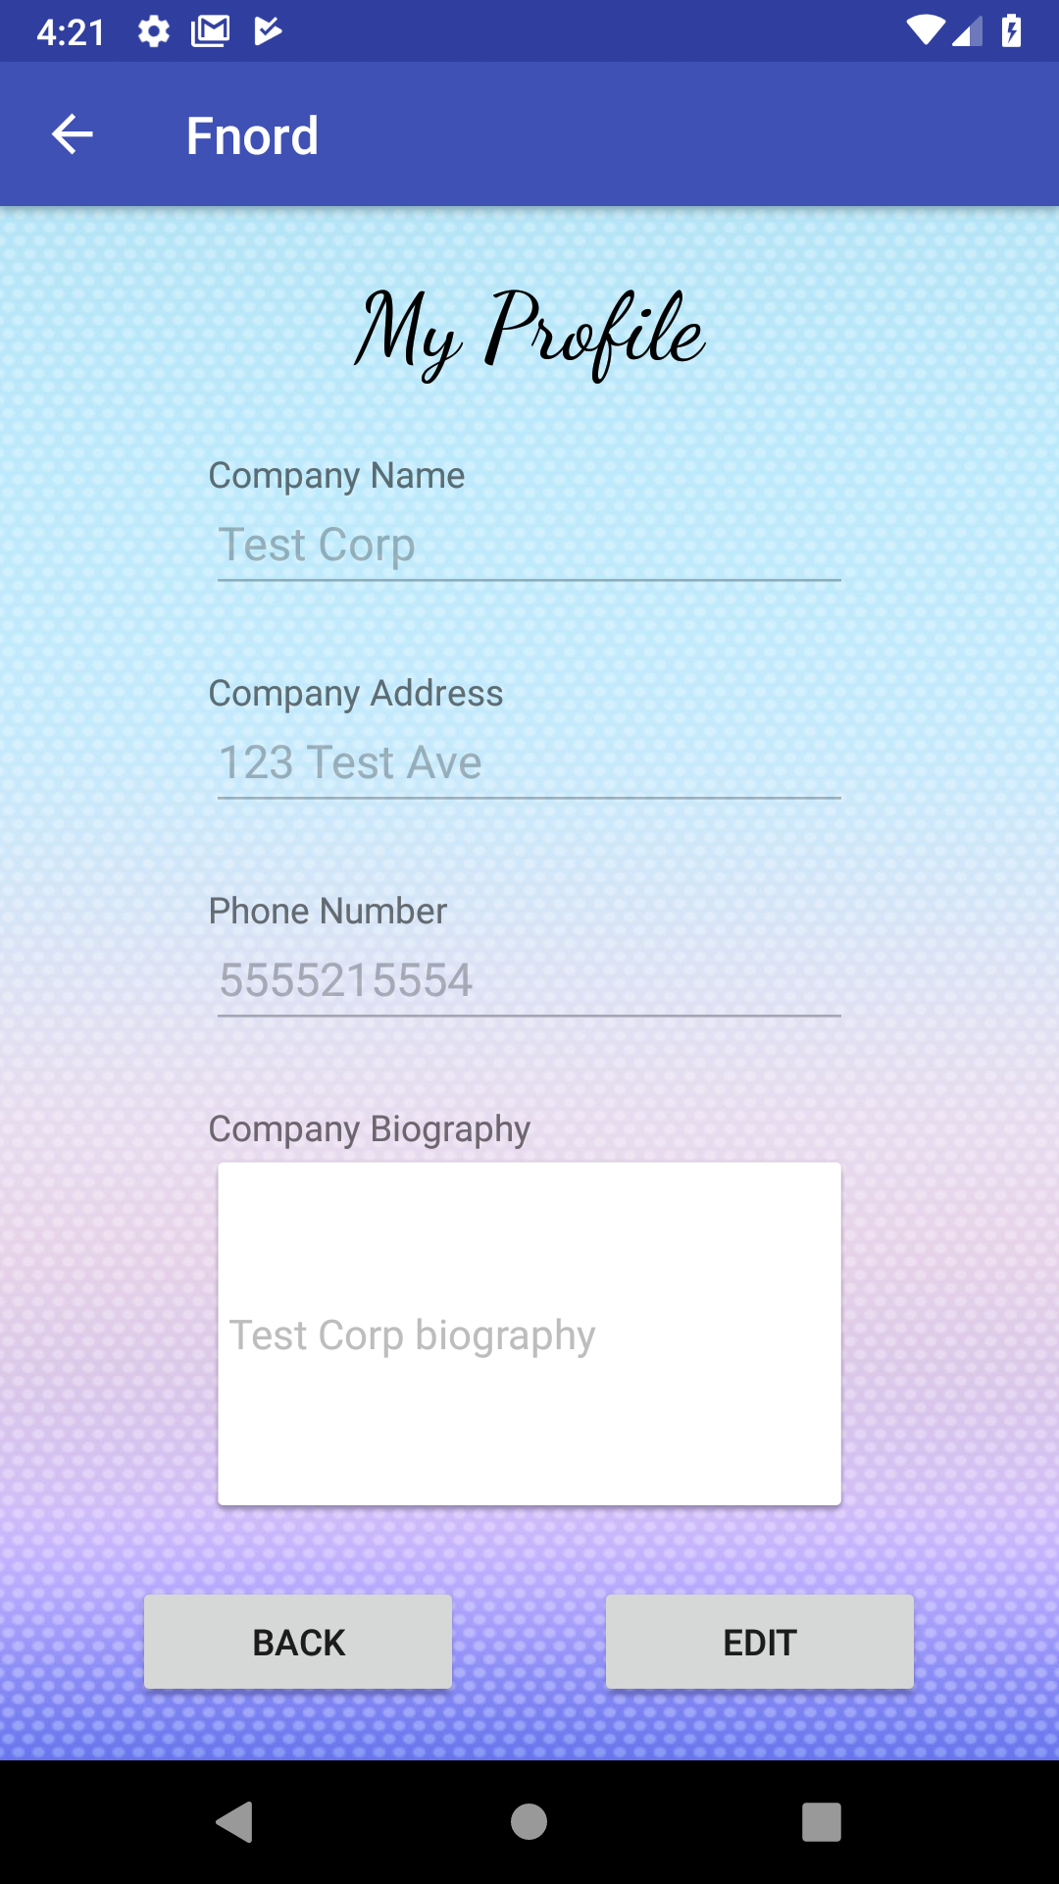 | View/Add service activity  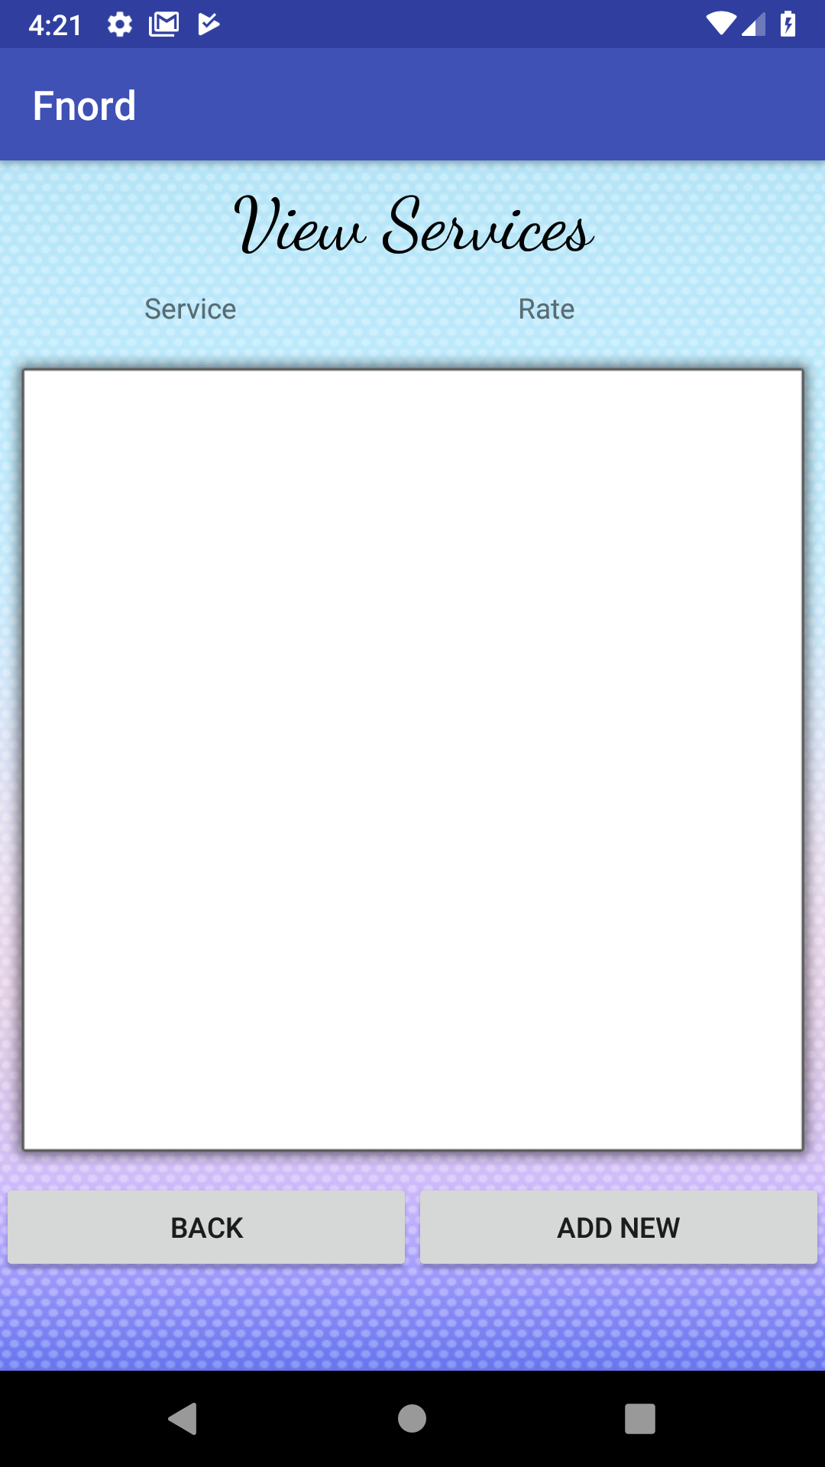
Availability activity  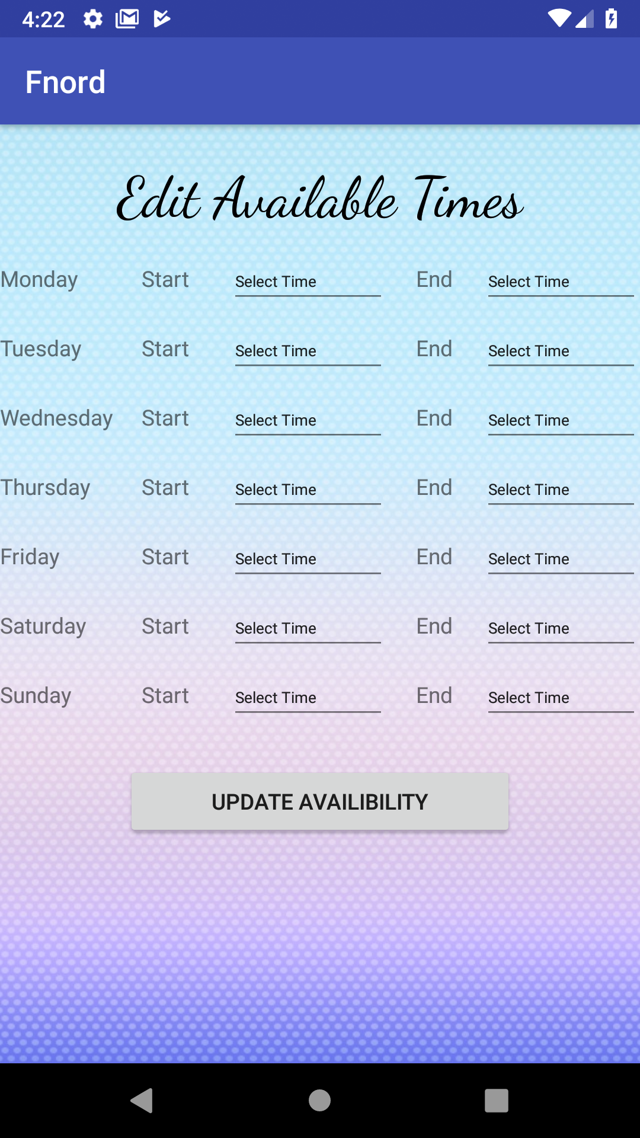 | Admin landing  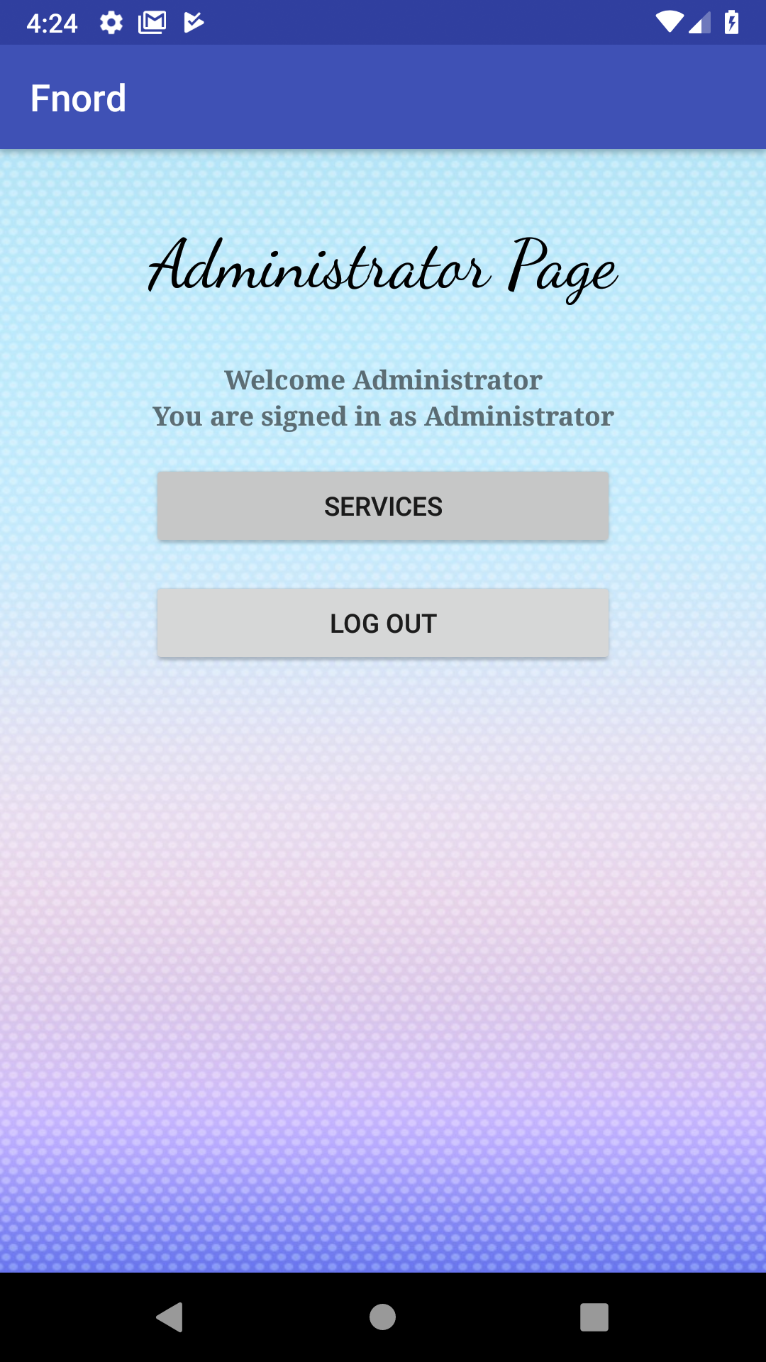 | Admin View/Edit services  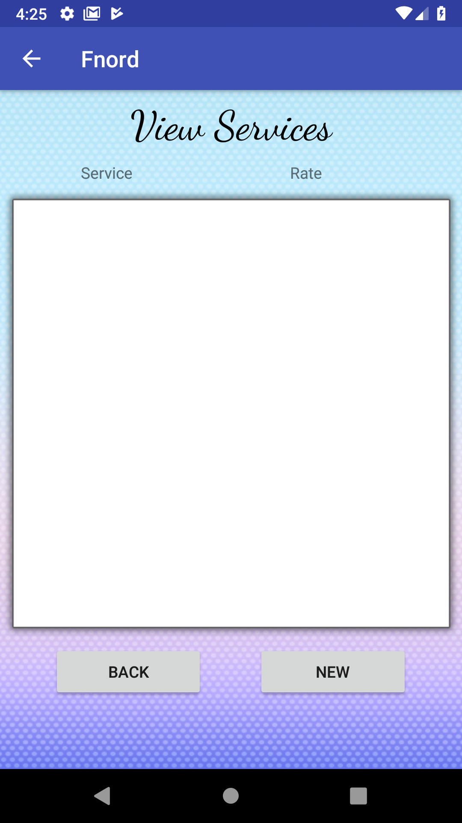
HomeOwner landing  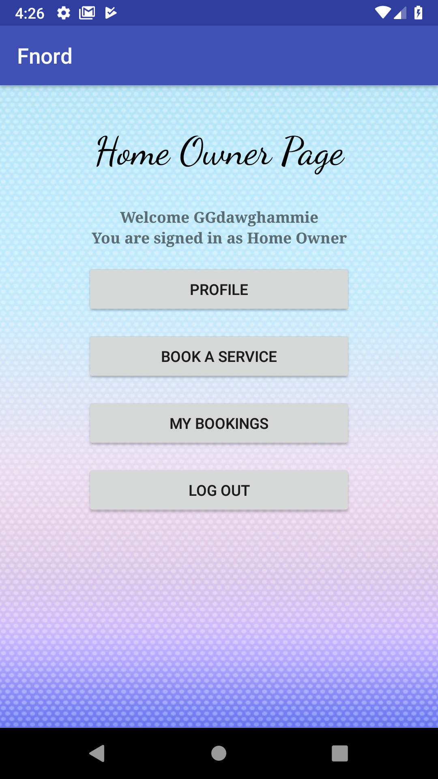 | HomeOwner profile activity  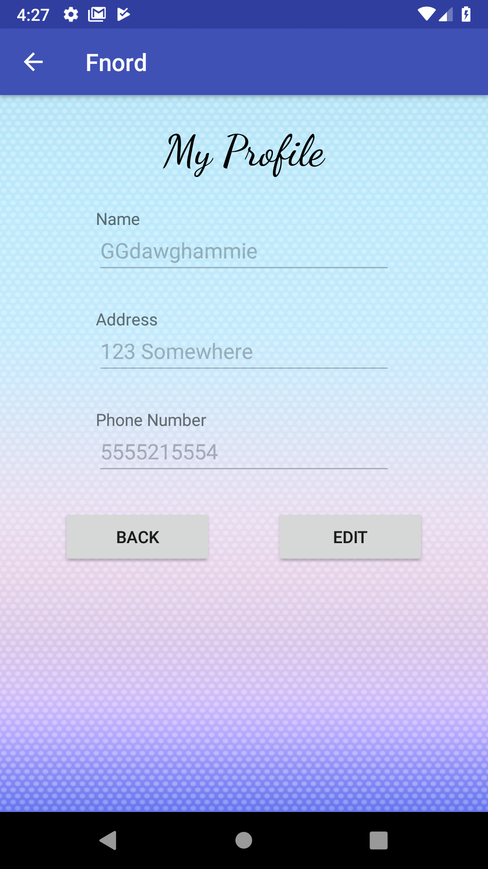 | HomeOwner Search activity  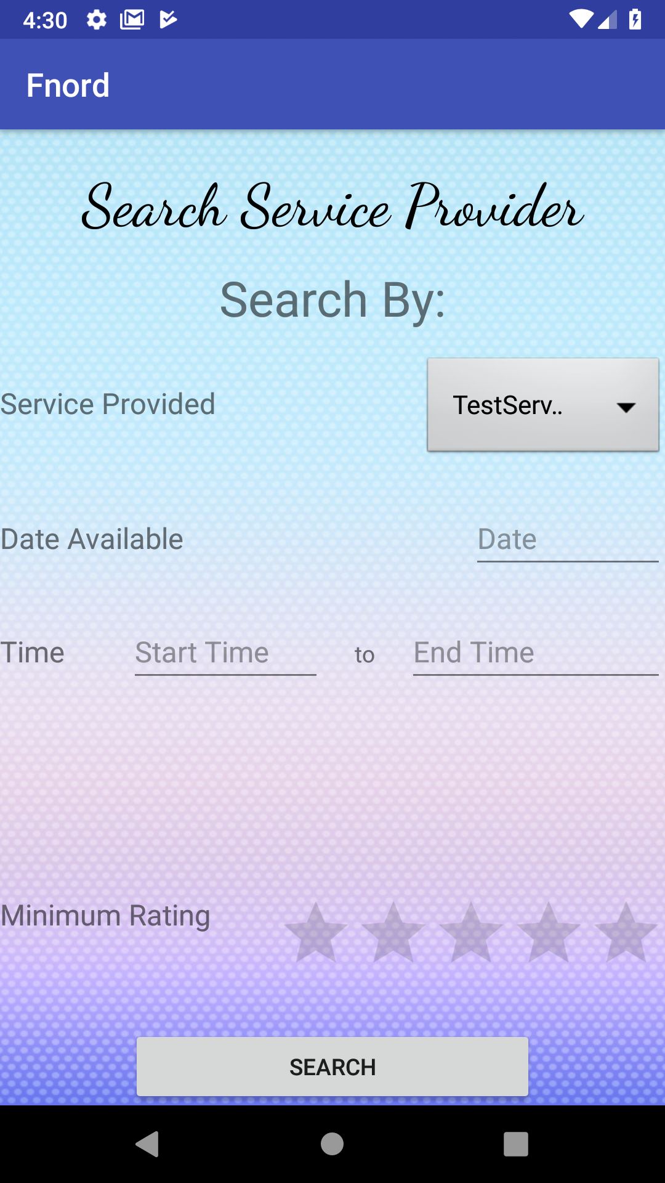
HomeOwner Search Results activity  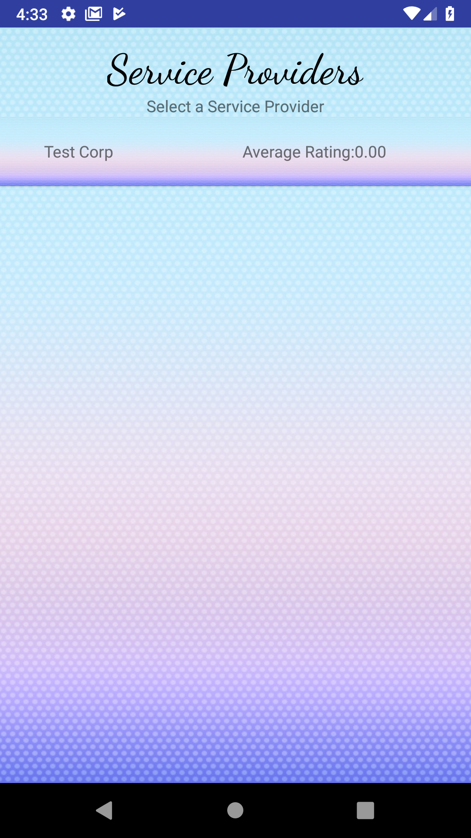 | HomeOwner ServiceProvider activity  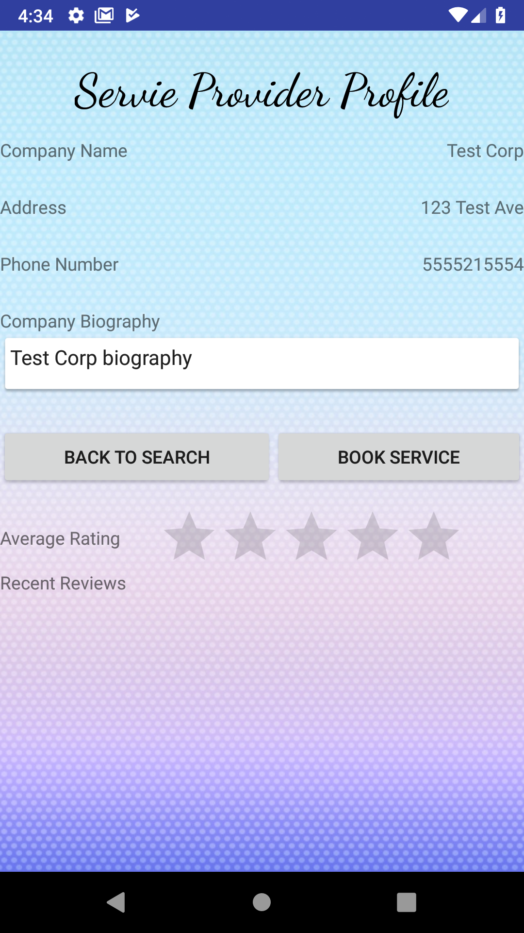 | HomeOwner Book Service activity  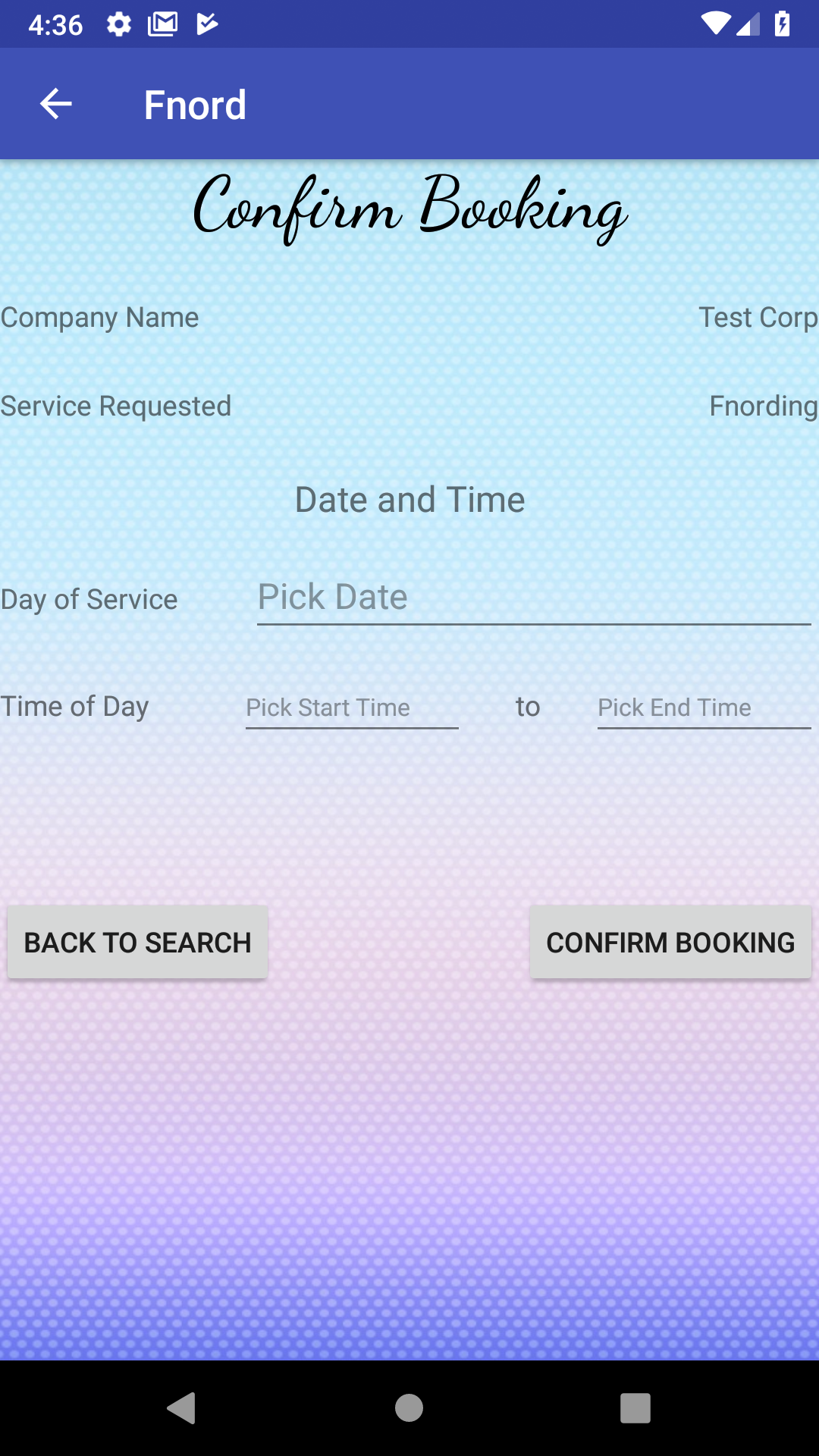
HomeOwner Bookings activity  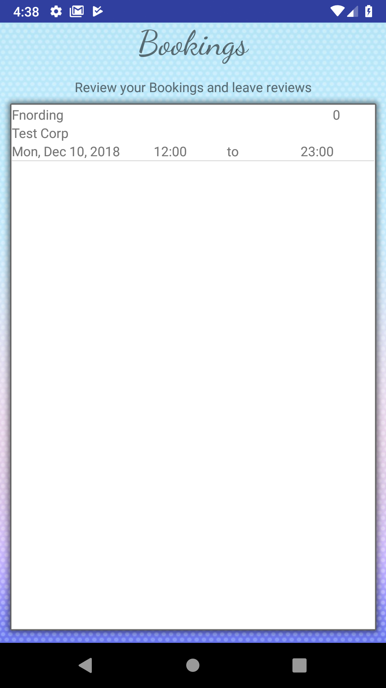 | HomeOwner rating activity  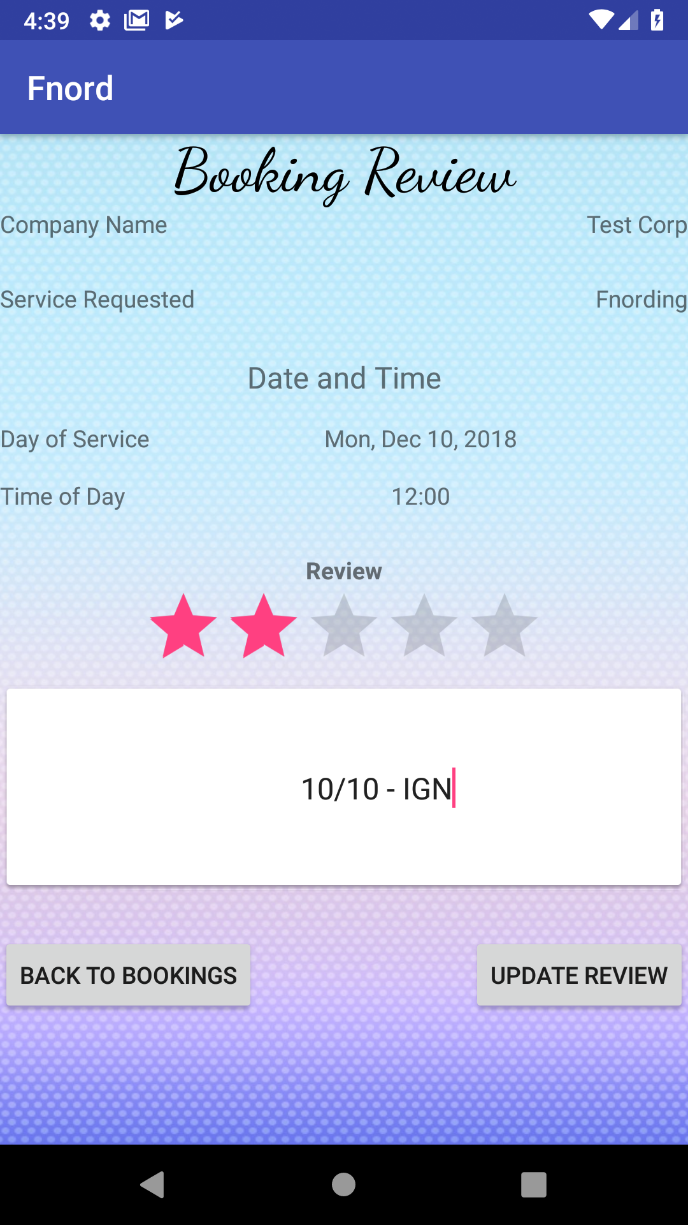

Lessons Learned
We learned that group communication to make sure everyone knows what’s happening and what needs to happen are very important in making sure the group can meet deadlines. Face to face meetings are quite effective in that regard.

Teamwork and a good team dynamic are integral to group projects. Having one person doing all the work is not feasible nor fair. Furthermore, if one person is stuck on something, the rest of the team can help them work it out instead of them staying stuck and causing the team to miss the deadline.

If we had to redo this project, we’d try to plan most of the features across all 4 deliverables from the start to reduce the amount of code refactoring. Code refactoring delayed the start of work on the next deliverable at least twice across the four deliverables, which could have easily been avoided with a bit more foresight.

